**Assignment 1**

1. What is JDK? JRE? JVM?

JDK: The Java Development Kit is a distribution of Java Technology by Oracle Corporation. It implements the Java Language Specification and the Java Virtual Machine Specification and provides the Standard Edition of the Java Application Programming Interface

JRE: The *Java Runtime Environment*, or *JRE*, is a software layer that runs on top of a computer’s operating system software and provides the *class libraries* and other resources that a specific [Java](https://www.ibm.com/cloud/learn/java-explained) program needs to run.

JVM: A **Java virtual machine** (**JVM**) is a [virtual machine](https://en.wikipedia.org/wiki/Virtual_machine) that enables a computer to run [Java](https://en.wikipedia.org/wiki/Java_(software_platform)) programs as well as programs written in [other languages](https://en.wikipedia.org/wiki/List_of_JVM_languages) that are also compiled to [Java bytecode](https://en.wikipedia.org/wiki/Java_bytecode). The JVM is detailed by a [specification](https://en.wikipedia.org/wiki/Specification_(technical_standard)) that formally describes what is required in a JVM implementation. Having a specification ensures interoperability of Java programs across different implementations so that program authors using the [Java Development Kit](https://en.wikipedia.org/wiki/Java_Development_Kit) (JDK) need not worry about the idiosyncrasies of the underlying hardware platform.

1. What is java compiler?

A **Java compiler** is a [compiler](https://en.wikipedia.org/wiki/Compiler) for the programming language [Java](https://en.wikipedia.org/wiki/Java_(programming_language)). The most common form of output from a Java compiler is [Java class files](https://en.wikipedia.org/wiki/Java_class_file) containing platform-neutral [Java bytecode](https://en.wikipedia.org/wiki/Java_bytecode),[[1]](https://en.wikipedia.org/wiki/Java_compiler#cite_note-1) but there are also compilers that output optimized [native machine code](https://en.wikipedia.org/wiki/Machine_code) for a particular hardware/[operating system](https://en.wikipedia.org/wiki/Operating_system) combination, most notably the now discontinued [GNU Compiler for Java](https://en.wikipedia.org/wiki/GNU_Compiler_for_Java).[[2]](https://en.wikipedia.org/wiki/Java_compiler#cite_note-2)

1. Why is java platform independent?

Java is platform-independent **because it uses a virtual machine**. The Java programming language and all APIs are compiled into bytecodes. Bytecodes are effectively platform-independent. The virtual machine takes care of the differences between the bytecodes for the different platforms.

1. What is IDE? Why is it important for developers?

An IDE, or Integrated Development Environment, **enables programmers to consolidate the different aspects of writing a computer program**. IDEs increase programmer productivity by combining common activities of writing software into a single application: editing source code, building executables, and debugging.

1. Is java case sensitive?

Yes

1. What do the following key words do?  
   static

Static method: method can be called without instantiating a class object.

Static variable: gets created when the first instance of the class gets created. There is only a copy of it and all the instances of this class share this copy.

Static block: used for static initialization of a class. This code inside the static block is executed only once: the first time the class is loaded into memory.

Static class:

A static inner class is **a nested class which is a static member of the outer class**. It can be accessed without instantiating the outer class, using other static members. Just like static members, a static nested class does not have access to the instance variables and methods of the outer class

final:

* [class] A final class can’t be inherited
* [method] A final method can’t be overridden
* [variable] A final variable value can’t be re-referenced.

public:

The public keyword is **an access modifier used for classes, attributes, methods and constructors**, making them accessible by any other class.

private:

The private keyword is **an access modifier used for attributes, methods and constructors, making them only accessible within the declared class**.

void:

The void keyword in Java **denotes that a method does not have a return type**

null:

* It is case-sensitive.
* It is a value of the reference variable.
* The access to a null reference generates a **NullPointerException.**
* It is not allowed to pass null as a value to call the methods that contain any primitive data type.

package:

package is a Java keyword. **It declares a 'name space' for the Java class**. It must be put at the top of the Java file, it should be the first Java statement line. To ensure that the package name will be unique across vendors, usually the company url is used starting in backword.

Class:

The class keyword is **used to declare a new Java class, which is a collection of related variables and/or methods**. Classes are the basic building blocks of object−oriented programming.

new:

The Java new keyword is **used to create an instance of the class**. In other words, it instantiates a class by allocating memory for a new object and returning a reference to that memory.

1. What is primitive type and reference type?

Primitive data types - includes **byte , short , int , long , float , double , boolean and char**.

All other types are reference types

1. Is parameter passed by value or reference?

**Java always passes parameter variables by value**

1. What is the output: System.out.println(1 > 0 : “A”:”B”);

A

1. How to define constants in java?

To define a variable as a constant, we just need to add the keyword “**final**” in front of the variable declaration.

1. What is String? Is it primitive type?

The **String** class represents character **strings**

No

1. How to check if a String is representing a number?

StringUtils.isNumeric

1. Write a program to implement the following activity diagram:

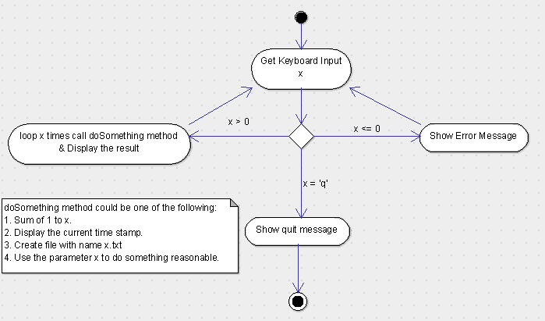

Class Solution {

public void solve() {

Scanner reader = new Scanner(System.in);

int x = reader.nextInt();

if (x>0) {

for (int i=0; i<x; ++i) {

int sum=0;

for (int j = 1; j<=x; ++j) {

sum +=j;

}

System.out.println(sum);

}

}

else if (x<=0) {

System.out.println(“Error”);

}

else if (x==’q’ – ‘a’) {

System.out.println(“Quit”);

}

}

}

1. Write a program to merge two array of int.
2. Write a program to find the second largest number inside an array of int.